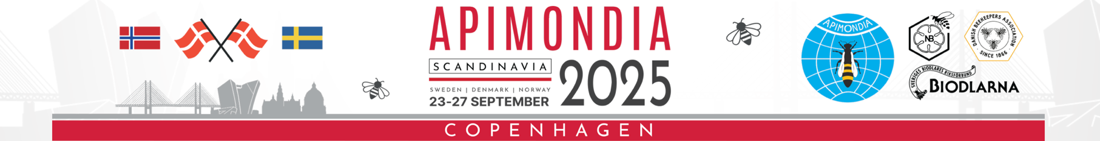
WBA Application Form
Entries will not be accepted in Denmark unless registered online until September 5th.
Name:  Surname: | Address:
Beekeeping Association –

Classes Entering (one can enter up to 3 entries per class but only win one prize) | Cost per entry
Section A. – MEAD  Class 1 –  Class 2 –  Class 3 –  Class 4 – | 50 EURO per entry  Class 1 –  Class 2 –  Class 3 –  Class 4 –
Section B. – BEESWAX  Class 5 –  Class 6 –  Class 7 -  Class 8 – | 50 EURO per entry  Class 5 –  Class 6 –  Class 7 –  Class 8 –
Section C. – DISPLAYS  Class 9 – | 50 EURO per entry  Class 9 -
Section D. – PHOTOGRAPHS  Class 10 –  Class 11 – | 50 EURO per entry  Class 10 –  Class 11 -
Section E. – PRINTED MATERIALS  Class 12 –  Class 13 –  Class 14 –  Class 15 –  Class 16 –  Class 17 –  Class 18 – | 50 EURO per entry  Class 12 –  Class 13 –  Class 14 –  Class 15 –  Class 16 –  Class 17 –  Class 18 –
Section F. – INNOVATIONS & INVENTIONS  Class 19 –  Class 20 –  Class 21 – | 50 EURO per entry  Class 19 –  Class 20 –  Class 21 –

